SPARK: Simple Play Adaptations to Reference for Kids

Giant Emotions Stamp Set
Description: | Image:
The stamp set includes ten 3" rubber stamps with comfort grip handles. The see-thru top of the stamps provide ease in placement. | 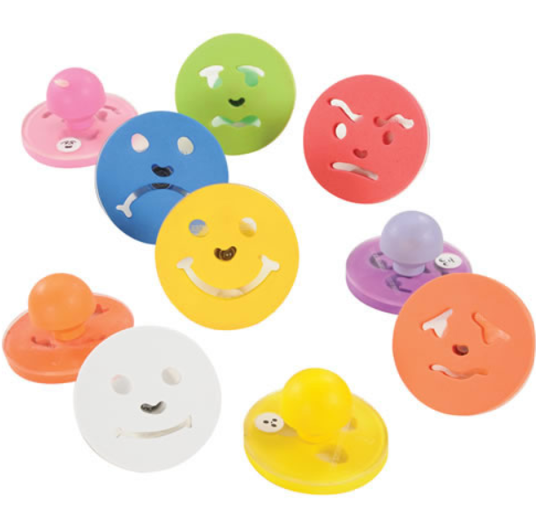  Purchasing Information

Who Might Benefit?
Those who…
• Have difficulty identifying their feelings.
• Need support determining what to do when they have certain feelings.
• Have motor challenges and are unable to draw pictures depicting feelings.

Why Use?
Provides an opportunity to…
• Talk about feelings.
• Show how they are feeling without talking.
• Engage in art activities which may include a discussion of emotions.
Instructions for Use: | Adaptation Ideas:
Environmental Considerations  - Some children might do better with a one-on-one discussion of feelings rather than in a whole group setting.  - A quiet, more private area of the classroom could be considered for a child who has difficulty talking about, or controlling their feelings.  Positioning  - These stamps can potentially be used in a variety of positions, however it is important that the user(s) are able to view them and reach them easily.  - Stamping activities work best when paper is secured on a solid, flat surface (ex. tabletop, floor, tray, easel, wall)  Alternate Positioning  - Tape paper being stamped on a vertical plane (easel, wall, bulletin board, filing cabinet) for children who may have difficulty seeing materials on a tabletop.  Basic Play/Use  - Provide ink pads or paint, paper, and stamps without specific directions, allow children to create, then talk about what they stamped and why.  - Stamps can be used to “start” a drawing or art project, then encourage the child to add additional details (hair, body, background) with markers, crayons, yarn, etc.  Extended Play/Use  - Stamp the various feelings on cardstock and cut around the stamp. Mount the stamped paper on craft sticks to create feelings puppets.  - During story time,have the children take turns identifying how a character in the story might feel by selecting one of the feeling puppets.  - Make up new words to the song “If You’re Happy and You Know It” and make sentence strips using the stamps along with the words to sing the verses (ex. “If you're sad and you know it, tell a friend”.  Play/Use with Others  - Have children stamp their presence on a large attendance chart choosing the stamp that best represents their feeling when they arrived.  - During group time, have them share their feeling and why they feel that way.  - If a child identifies a feeling other than “happy” or “surprised”, encourage the group to talk about what could be done to make the child feel better.  - Take pictures of the children making faces to express emotions. Print, laminate, and bind to make a Feelings book for the classroom library. See OCALI Social Narrative Example, Feeling Anxious and Worried. | Optional Additional Materials/Supplies  - Velcro  - Foam Board  Build It Up  - Build up stamp handles.  Stabilize It  - Create loop or cuff around stamp handle for children who have difficulty grasping.  - Tape paper down.  Simplify It  - Reduce the number of emotions discussed (ex. happy, sad, mad, sick, scared) or stamps being used based on the child’s understanding.  Add Sensory Cues  - Add textures to the handles of the stamps for additional sensory information.  Alternative Uses  - Use stamps and index cards to create a Feelings Match card game.  - Stamp one feeling per page, label it, and provide magazines or precut pictures for children to make a collage of matching pictures  DIY Alternatives  - Make a giant Feelings Wheel on foam board and add a dial for children to indicate their feelings.

Resources:

See Social Narratives from OCALI’s Autism Center Grab and Go Resource Gallery of Interventions.
- For further information, visit the Social Narratives Autism Internet Module.
- Like Social Stories, Power Cards teach and reinforce academic, behavioral, organizational, and social skills. Power Cards are visual supports that include an individual’s special interest. See Power Cards from OCALI’s Autism Center Grab and Go Resource Gallery of Interventions.
- Reminder Cue Cards from OCALI’s Autism Center Grab and Go Resource Gallery of Interventions help teach and remind individuals how to engage in positive behaviors. Reminder Cue Cards provide “what to do” suggestions when an individual is feeling anxious, stressed, or confused. They also support interactions with peers, and offer ways to self-regulate, and manage emotions.
- Practical Strategy for Teachers/Caregivers: Teaching Social Emotional Skills from the Center on the Social Emotional Foundations for Early Learning.

Ohio Early Learning Standards:
- SE: Self Awareness: Develops an understanding of emotions (1.b.).
- SE: Self Awareness: Begins to manage emotions and actions (2.a.).
- SE: Social Awareness: Develops empathy toward and understanding of others (3 a.).
- SE: Relationship Skills: Develops ability to use simple strategies to resolve conflicts with peers (4.c.).
- CR: Artistic Engagement and Expression: Expresses ideas and feelings through visual art (1.a.).

Words to Encourage Play/Use
I feel  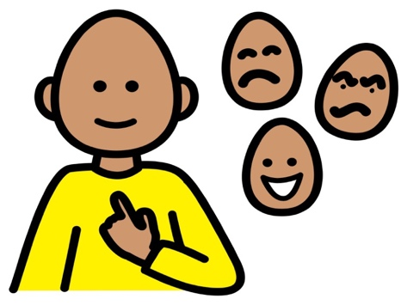 | Happy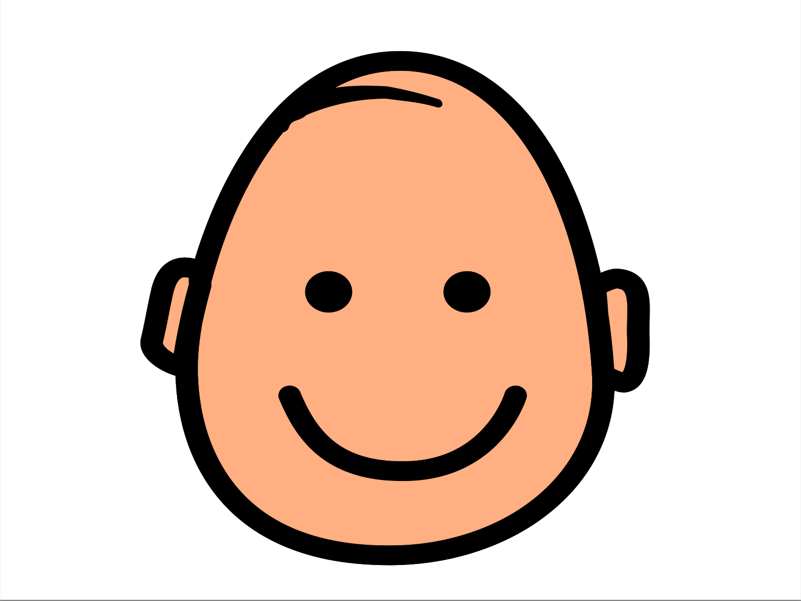 | Sad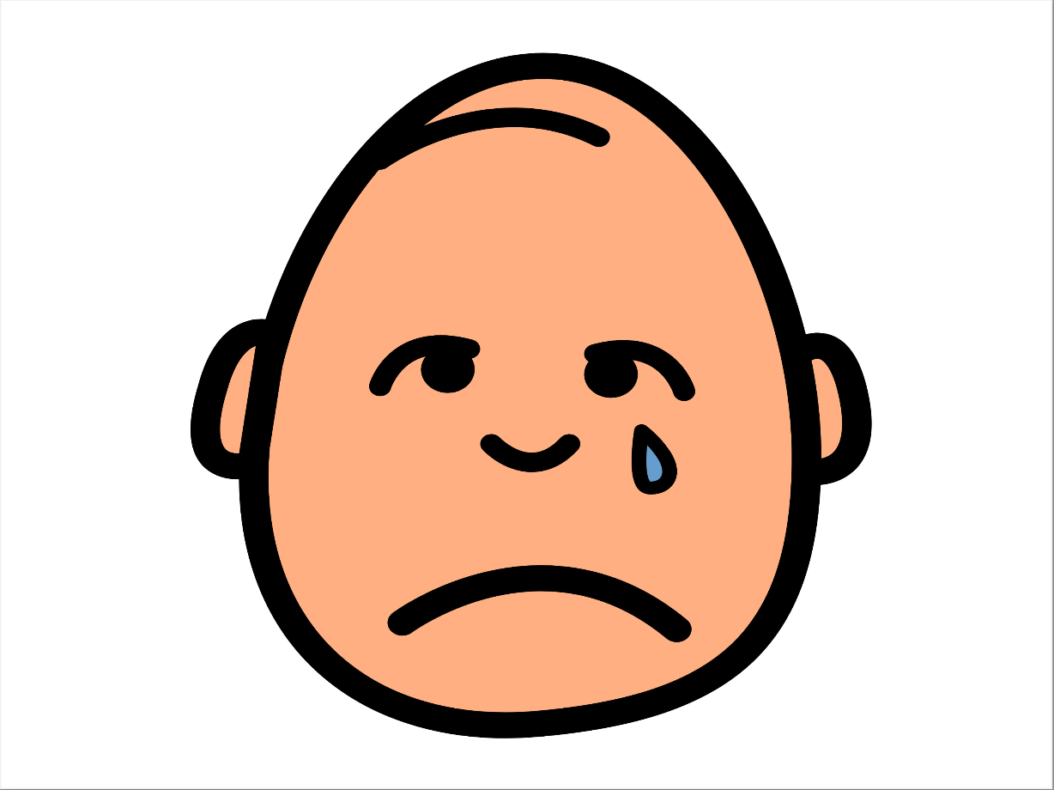
Sick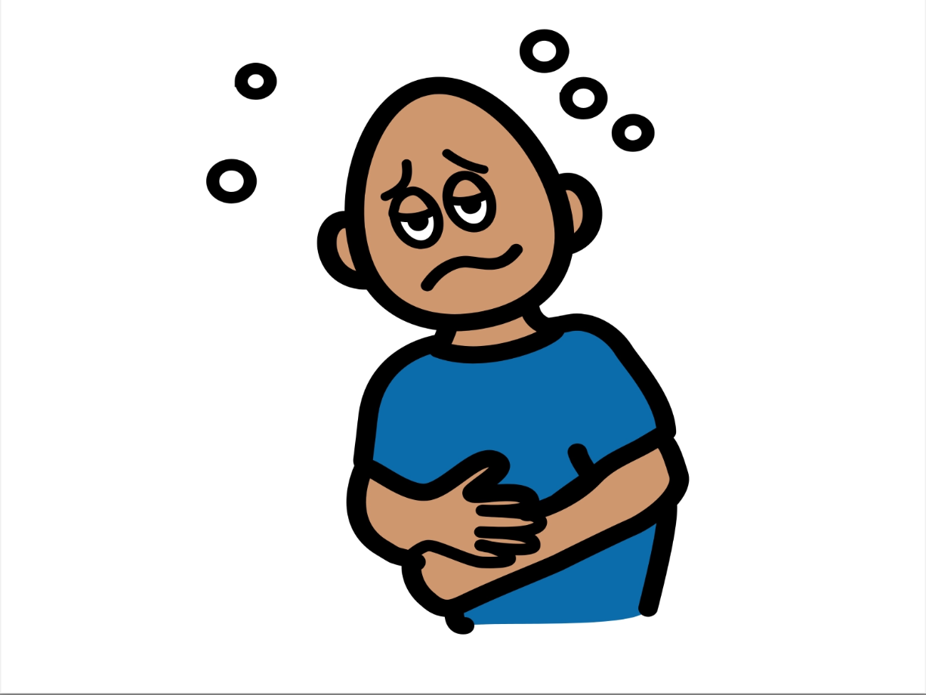 | Surprised | Tired 
Confused | Mad | Scared  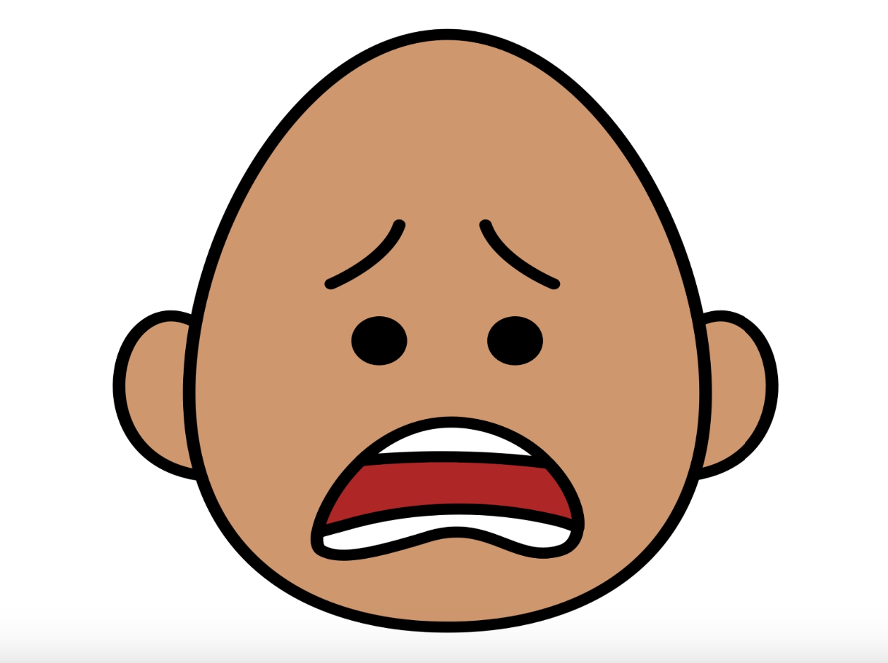
*”Adaptations” adapted from: Haugen’s Modes for Adapting Toys based on materials from the "Let's Play" Project at the University of Buffalo
PCS is a trademark of Tobii Dynavox, LLC. All rights reserved. Used with permission.

